# Octet Range

# 11111111. 11111111. 11111111. 11111111.

# 2^8. 2^8. 2^8. 2^8.

# 255.255.255.255

**Classless inter-domain routing(CIDR)**

**Classless inter-domain routing** (CIDR) is a set of Internet protocol (IP) standards that is used to create unique identifiers for networks and individual devices. The IP addresses allow particular information packets to be sent to specific computers.

# IPv4 - Address Classes

Internet Protocol hierarchy contains several classes of IP Addresses to be used efficiently in various situations as per the requirement of hosts per network. Broadly, the IPv4 Addressing system is divided into five classes of IP Addresses. All the five classes are identified by the first octet of IP Address.

Internet Corporation for Assigned Names and Numbers is responsible for assigning IP addresses.

The first octet referred here is the left most of all. The octets numbered as follows depicting dotted decimal notation of IP Address:

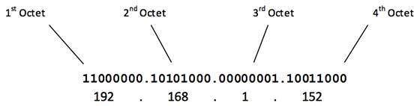

The number of networks and the number of hosts per class can be derived by this formula:

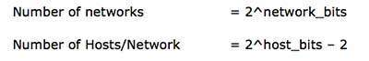

When calculating hosts' IP addresses, 2 IP addresses are decreased because they cannot be assigned to hosts, i.e. the first IP of a network is network number and the last IP is reserved for Broadcast IP.

## Class A Address

The first bit of the first octet is always set to 0 (zero). Thus the first octet ranges from 1 – 127, i.e.

Class A Addresses

Class A addresses only include IP starting from 1.x.x.x to 126.x.x.x only. The IP range 127.x.x.x is reserved for loopback IP addresses.

127.0.0.1

The default subnet mask for Class A IP address is 255.0.0.0 which implies that Class A addressing can have 126 networks (27-2) and 16777214 hosts (224-2).

Class A IP address format is thus: **0NNNNNNN**.HHHHHHHH.HHHHHHHH.HHHHHHHH

## Class B Address

An IP address which belongs to class B has the first two bits in the first octet set to 10, i.e.

Class B Addresses

Class B IP Addresses range from 128.0.x.x to 191.255.x.x. The default subnet mask for Class B is 255.255.x.x.

Class B has 16384 (214) Network addresses and 65534 (216-2) Host addresses.

Class B IP address format is: **10NNNNNN.NNNNNNNN**.HHHHHHHH.HHHHHHHH

## Class C Address

The first octet of Class C IP address has its first 3 bits set to 110, that is:

Class C Addresses

Class C IP addresses range from 192.0.0.x to 223.255.255.x. The default subnet mask for Class C is 255.255.255.x.

Class C gives 2097152 (221) Network addresses and 254 (28-2) Host addresses.

Class C IP address format is: **110NNNNN.NNNNNNNN.NNNNNNNN**.HHHHHHHH

## Class D Address

Very first four bits of the first octet in Class D IP addresses are set to 1110, giving a range of:

Class D Addresses

Class D has IP address rage from 224.0.0.0 to 239.255.255.255. Class D is reserved for Multicasting. In multicasting data is not destined for a particular host, that is why there is no need to extract host address from the IP address, and Class D does not have any subnet mask.

## Class E Address

This IP Class is reserved for experimental purposes only for R&D or Study. IP addresses in this class ranges from 240.0.0.0 to 255.255.255.254. Like Class D, this class too is not equipped with any subnet mask.

# IPv4 - Subnetting

Each IP class is equipped with its own default subnet mask which bounds that IP class to have prefixed number of Networks and prefixed number of Hosts per network. Classful IP addressing does not provide any flexibility of having less number of Hosts per Network or more Networks per IP Class.

CIDR or **Classless Inter Domain Routing** provides the flexibility of borrowing bits of Host part of the IP address and using them as Network in Network, called Subnet. By using subnetting, one single Class A IP address can be used to have smaller sub-networks which provides better network management capabilities.

## Class A Subnets

In Class A, only the first octet is used as Network identifier and rest of three octets are used to be assigned to Hosts (i.e. 16777214 Hosts per Network). To make more subnet in Class A, bits from Host part are borrowed and the subnet mask is changed accordingly.

For example, if one MSB (Most Significant Bit) is borrowed from host bits of second octet and added to Network address, it creates two Subnets (21=2) with (223-2) 8388606 Hosts per Subnet.

The Subnet mask is changed accordingly to reflect subnetting. Given below is a list of all possible combination of Class A subnets:

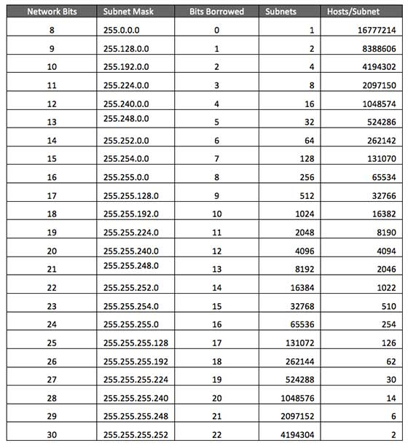

In case of subnetting too, the very first and last IP address of every subnet is used for Subnet Number and Subnet Broadcast IP address respectively. Because these two IP addresses cannot be assigned to hosts, sub-netting cannot be implemented by using more than 30 bits as Network Bits, which provides less than two hosts per subnet.

## Class B Subnets

By default, using Classful Networking, 14 bits are used as Network bits providing (214) 16384 Networks and (216-2) 65534 Hosts. Class B IP Addresses can be subnetted the same way as Class A addresses, by borrowing bits from Host bits. Below is given all possible combination of Class B subnetting:

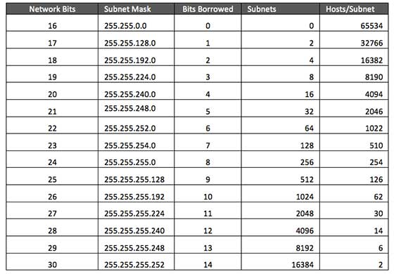

## Class C Subnets

Class C IP addresses are normally assigned to a very small size network because it can only have 254 hosts in a network. Given below is a list of all possible combination of subnetted Class B IP address:

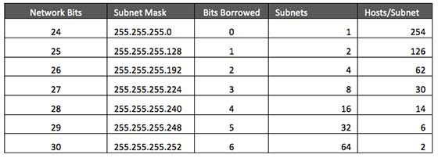

Manage Azure Virtual Networks and Windows Virtual Machines with Azure PowerShell

Azure virtual machines use Azure networking for internal and external network communication. This tutorial walks through deploying two virtual machines and configuring Azure networking for these VMs. The examples in this tutorial assume that the VMs are hosting a web application with a database back-end, however an application is not deployed in the tutorial. In this tutorial, you learn how to: